**PURBANCHAL UNIVERSITY**

**Biratnagar Nepal**



A Project report on

**“ELECTORAL MANAGEMENT SYSTEM”**

In the partial fulfillment for the requirement of the 2nd Semester Project-II (subject code- BIT 156CO) in the completion of Bachelor of Information Technology (BIT) degree at KIST college of Information Technology, under Purbanchal University.

|  |  |  |  |  |  |  |  |  |
| --- | --- | --- | --- | --- | --- | --- | --- | --- |
|  | **Submitted By:-** | | |  | | **Submitted To:-** | | |
| **1)** |  | **Priya Kushawaha** |  | |  | |  |  | |
| **2)** |  | **Samira Shahi** | | | **Purbanchal University** | | | | |

**Under The Guidance of**

**Mr. Deepak Khadka**

**Program Coordinator, BIT**

**KIST COLLEGE OF INFORMATION AND TECHNOLOGY KAMALPOKHARI, KATHMANDU NEPAL**

**KIST COLLEGE OF INFORMATION AND TECHNOLOGY KAMALPOKHARI, KATHMANDU NEPAL**



**CERTIFICATE**

This is to certify that the project work entitled **“ELECTORAL MANAGEMENT SYSTEM”** is carried out by **PRIYA KUSHAWAHA (5431), SAMIRA SHAHI (5434),** bona fide students of **KIST COLLEGE OF INFORMATION AND TECHNOLOGY** in partial fulfil2 `1lment for the award of **BACHELOR IN INFORMATION AND TECHNOLOGY** of the **PURBANCHAL UNIVERSITY, BIRATNAGAR NEPAL**, during the year **2021-2022**. It is certified that all corrections indicatedfor internal assessment have been incorporated in the report submitted in the department library. The project report has been approved, as it satisfied the academic requirements in respect of the project work prescribed for the said degree.

The details of the students are as follows:-

|  |  |  |
| --- | --- | --- |
| **NAME** | **REGISTRATION NO.** | **SYMBOL NO.** |
| Priya Kushawaha | 058-3-2-04730-2020 | 324627 |
| Samira Shahi | 058-3-2-04737-2020 | 324634 |
|  |  |  |
|  |  |  |

Course Semester: - 2nd Semester

Subject: - Project-II

Subject Code: - BIT (156CO)



Mr. Deepak Khadka

Program Coordinator, BIT



**KIST COLLEGE OF INFORMATION AND TECHNOLOGY KAMALPOKHARI, KATHMANDU**

**Examiner’s Certification**

The Project Report

On

**“ELECTORAL MANAGEMENT SYSTEM”**

**Developed by**

**Priya Kushawaha**

**Samira Shahi**

Is approved and is acceptable in qualify form.

**Internal Examiner External Examiner**

Name: Name:

Designation: Designation:

**ACKNOWLEDGEMENT**

It is with greatest satisfaction and euphoria that we are submitting our project report entitled **“ELECTORAL MANAGEMENT SYSTEM”.** We have completed it as a part of the curriculum of **PURBANCHAL UNIVERSITY.**

We would like to express our deepest appreciation to all those who provided us the possibility to complete this project.  A special gratitude to our **PROJECT MANAGER** and **COORDINATOR Mr. Deepak Khadka** who guided us throughout the project. We would also like to thank our friends and family who continuously supported, motivated us and offered deep insight into the study.

We are indebted to all members of **KIST College,** for the valuable support and suggestion provided by them using their specific fields’ knowledge. We are grateful for their cooperation during the period of our project..

Finally, we would also like to express our gratitude to **PURBANCHAL UNIVERSITY** who gave us the beautiful opportunity to explore on this wonderful project. This project helped us in doing a lot of research and we came to know about so many new things we are really thankful.

We hope university will accept our attempt as a successful project.

Thank you!

**PRIYA KUSHAWAHA (324627)**

**SAMIRA SHAHI (324634)**

**STUDENT’S DECLARATION**

We hereby declare that the project report entitled **“ELECTORAL MANAGEMENT SYSTEM”** is based on our own work carried out during the course of our study under the supervision of **Mr. DEEPAK KHADKA** sir**.** We assert the statements made and conclusions drawn are an outcome of our research work.

Furthermore, we certify that this project submitted is our original work and has never been submitted in any institution for any other titles or awards.

|  |  |  |  |
| --- | --- | --- | --- |
| **S.N.** | **Name** | **Registration No.** | **Symbol No.** |
| 1. | Priya Kushawaha | 058-3-2-04730-2020 | 324627 |
| 2. | Samira Shahi | 058-3-2-04737-2020 | 324634 |

**TO WHOM IT MAY CONCERN**

This is to certify that Ms. Priya Kushawaha and Ms. Samira Shahi of **Bachelor in Information Technology** (**BIT**) has studied as per the curriculum of BIT 2nd Semester and completed the project entitled **“ELECTORAL MANAGEMENT SYSTEM”**.This project is the original work of Ms. Priya Kushawaha and Ms. Samira Shahi and was carried out under the supervision of Mr. **Deepak Khadka** as per the guidelines provided by Purbanchal University and certified as per the student’s declaration that project **“ELECTORAL MANAGEMENT SYSTEM”** has not been presented anywhere as a part of any other academic work.

The detail of the student is as follows:

Name of Students : Priya Kushawaha

Samira Shahi

Semester : 2nd

Subject Code : BIT 156C0

Project Title : **Electoral Management System**

…………………………….

Mr. Deepak Khadka  
Program Coordinator, BIT  
KIST College of Information Technology

**Table of Contents**

ABSTRACT 9

CHAPTER 1 10

INTRODUCTION 10

1.1 Motivation 10

1.2 Programming language 10

1.3 C++ language 10

1.4 Advantages of C++ language 10

1.6 Project description 10

1.7 Introduction to Electoral process management 11

1.8 Problem Statement 11

1.9 Objectives 11

1.10 Scope 11

CHAPTER 2 12

MATERIALS AND METHOD 12

2.1 Header files 12

2.2 Functions used 12

2.3 Switch case 13

CHAPTER 3 15

SYSTEM DESIGN 15

3.1Algorithm 15

3.2Flowchart 17

ER DIAGRAM 19

CHAPTER 4 20

REQUIREMENT ANALYSIS & IMPLEMENTATION SYSTEM 20

4.1 Requirements 20

4.2 System Methodology 21

4.2.1 Requirement analysis 22

Functional requirement 22

4.2.2. System design 23

4.2.2.1 Functional analysis 23

4.2.3. Implementation 24

4.2.4. Integration and testing 24

4.2.5. Deployment and maintenance 24

CHAPTER 5 25

CONCLUSION AND FUTURE SCOPE 25

5.1Conclusion 25

5.2 Future scope 25

REFERENCES 26

Chapter 6 27

Appendix 27

Screenshots 27

Chapter 7 31

Source Code 31

# ABSTRACT

Election is a process in which people vote to choose a person or group of people to hold an official position. The word “vote” means to choose from a list, to elect or to determine. The main goal of voting (in a scenario involving the citizens of a given country) is to come up with leaders of the people’s choice. Most countries, have problems when it comes to voting. Some of the problems involved include ridging votes during election, insecure or inaccessible polling stations, inadequate polling materials and also inexperienced personnel.

In our country, we still follow paper based voting and it’s very big problem. This coded project easily depicts the management that is required to handle such a big program conducted all over the country. The project has a set format as to how the voter registers, how he casts his vote and how the party with maximum votes wins the elections by fair chance. It is an electronic world and hence this program helps in demising the use of paper ballot. And minimizes the labor required while counting the votes.

He/She has to be registered first for him/her to vote. Registration is done by the individuals themselves. After registration, the voter is assigned a secret Voter ID with which he/she can use to log into the system and enjoy services provided by the system such as voting. In this system people who have citizenship of their country and whose age is above 18 years of age and any sex can caste the vote. The project is beneficial for Election Commission, Voters as the can get to know the candidate background and choose wisely, and even for Candidate.

# CHAPTER 1

# INTRODUCTION

## 1.1 Motivation

We found that we were good at coding and had the ability to reason about the code very well and it didn't take long for us to realize that this is what we wanted to do for the rest of our life. Though when we began college we still wanted to go into programming, as the state of web applications became more interesting in the last few days, we got into that and that's what we are doing now! We really couldn't imagine doing anything else, and programming is definitely one of the top skills too.

## 1.2 Programming language

A programming language is a formal language that specifies a set of instructions that can be used to produce various kinds of output. Programming languages generally consist of instructions for a computer. Programming languages can be used to create programs that implement specific algorithms.

## 1.3 C++ language

C++ is a general-purpose object-oriented programming (OOP) language, developed by Bjarne Stroustrup, and is an extension of the C language. It is therefore possible to code C++ in a "C style" or "object-oriented style." In certain scenarios, it can be coded in either way and is thus an effective example of a hybrid language.

## 1.4 Advantages of C++ language

* Modularity: Dividing a program into small pieces 0 also called as divide and conqueror According to their operations into small modular.
* Re-usability: write code once and use more than one time.
* Readability:  Easy to read or understand.

**1.5 Limitations of C++ language**

* Data is global or local.
* Its emphasis is on instructions, but not on data.

## 1.6 Project description

The main aim of designing and developing this Internet Electoral Process Management primarily based Engineering project is to provide secure and efficient methods for casting vote using technology. C++ language is used to develop this project. Users will have all options and features in the application like registration, vote, and also there will be an additional option for the Electoral manager to access the final results.

## 1.7 Introduction to Electoral process management

The “Electoral Process Management System” is a modern developed system to cast a vote. It depicts the development taking in the field of technology which are improving our lifestyles. This system includes all the processes that takes place in an actual voting process, like displaying all the competing parties and their respective representatives, also it contains a separate window for electoral manager which contains all the necessary details like number of votes casted, total number of votes gained by all parties, and hence the final result.

Also this system is much more secure than the other systems as it gives the voter a one-time password which he or she uses at the time of casting vote. Electronic identity systems are being developed to ensure that citizens can participate in the new electronic world of commerce and government.  As more and more daily activities such as paying bills and consulting bank accounts is done electronically, the need to secure reliable electronic identity systems pressure the development and implementation of country-wide and world-wide methods of uniquely identifying people by electronic means

This system is much more useful than the paper ballot system used in old days. This remarkable step for the development in electronics and technology.

## 1.8 Problem Statement

* Expensive and time consuming
* Errors during data entry
* Too much paper work
* Loss of data due to paper work

## 1.9 Objectives

The main objectives of this project is to cast vote, where people , user, voters can vote their favourite candidates and helps them to win the election. It also helps to manage the vote counts. User can view the vote counts.

Objectives of the projects are as follow:-

* To register the voters details
* To caste vote
* Store vote counts
* To know the candidates details

### 1.10 Scope

This project has a large scope as it has the following features which help in making it easy to use, understand and modify it:

* The demise of ballot paper.
* The rise of electronic voting methods
* Electronic identities.
* To increment the precision and productivity of the arrangement technique.

# CHAPTER 2

# MATERIALS AND METHOD

## 2.1 Header files

|  |  |
| --- | --- |
| #include<iostream.h> | <iostream> contains the definition of basic_iostream class template, which implements formatted input and output, and includes <ios>, <istream> and <ostream>. |
| #include<conio.h> | The conio.h header is used to console input/output. |
| #include<stdlib.h> | stdlib.h is the header of the general purposestandard library of C++ programming language which includes functions involving memory allocation, process control, conversions and others. |
| #include<fstream> | Stream class to both read and write from/to files. |

**Table 2.1 Header files**

## 2.2 Functions used

|  |  |
| --- | --- |
| **void choice()** | To enter all the options displayed on the home screen. |
| **void reg()** | To display all the details required for registration of the user. |
| **void vote()** | To display all the competing parties and their respective representatives . |
| **void gen()** | To generate login id and password of the user. |
| **void log()** | To ask the login id and password of the electoral manager. |
| **void votec()** | To count the number of votes casted for respective parties. |
| **void tc()** | To count the total number of votes and hence display the winner. |
| **void know()** | To know the details of the candidates and hence helps the voters to cast the vote to the candidate they like. |

**Table 2.2 Functions**

## 2.3 Switch case

Switch statement is used to solve multiple option type problems for menu like program, where one value is associated with each option. The expression in switch case evaluates to return an integral value, which is then compared to the values in different cases, where it matches that block of code is executed, if there is no match, then default block is executed.

EXAMPLE:

switch(opt)

{

case 1:

cout<<"The current representative is: KP SHARMA OLI";

p1++;

break;

case 2:

cout<<"The current representative is: SHER BAHADUR DEUBA";

p2++;

break;

case 3:

cout<<"The current representative is: PUSHPA KAMAL DAHAL";

p3++;

break;

case 4:

cout<<"The current representative is: MADHAV KUMAR NEPAL";

p4++;

break;

case 5:

cout<<"The current representative is: UPENDRA YADAV";

p5++;

break;

case 6:

cout<<"The current representative is: MAHANTHA THAKUR";

p6++;

break;

case 7:

cout<<"The current representative is: RAJENDRA PRASAD LINGDEN";

p7++;

break;

case 8:

cout<<"The current representative is: HRIDAYESH TRIPATHI";

p8++;

break;

case 9:

cout<<"The current representative is: CHITRA BAHADUR K.C.";

p9++;

break;

case 10:

cout<<"The current representative is: NARANYAN MAN BIJUKCHHE";

p10++;

break;

case 11:

cout<<"The current representative is: RAVI LAMICHHANE";

p11++;

break;

default:

cout<<"select a valid option";

}

# CHAPTER 3

# SYSTEM DESIGN

## 3.1Algorithm

Algorithm is a process or set of rules to be followed in calculation or other problem solving operations, especially by a computer.

**Algorithm for Main Menu**

Step 1: Start

* Step 2: Press enter key to continue or escape to exit
* Step 3: After pressing enter key, Displays Main Menu with different Options like:-

1. Register
2. Vote
3. Electoral Manager
4. Know Your Candidate
5. Escape to exit

* Step 4: Press 1 to register
* Step 5: Press 2 to vote
* Step 6: Press 3 to enter Electoral Manager
* Step 7: Press 4 to Know Your Candidate
* Step 8: Press 5 to exit the program
* Step 9: Stop
* **Algorithm To Register**

Step1: Start

* Step2: Press enter key to continue or escape to exit
* Step3: After pressing enter key, Displays Main Menu with different Options like:-

1. Register
2. Vote
3. Electoral Manager
4. Know Your Candidate
5. Escape to Exit

Step4: Press 1 to register

Step5: Enter the details required

Step6: Stop

**Algorithm To Vote**

Step1: Start

* Step2: Press enter key to continue or escape to exit
* Step3: After pressing enter key, Displays Main Menu with different Options like:-

1. Register
2. Vote
3. Electoral Manager
4. Know Your Candidate
5. Escape to Exit

Step4: Press 2 to vote

Step5: Enter your Id and Password

Step6: After entering correct Id and Password, choices of different party will be displayed

Step7: Choose the party you want to vote

Step8: Stop

**Algorithm for Electoral Manager**

Step1: Start

* Step2: Press enter key to continue or escape to exit
* Step3: After pressing enter key, Displays Main Menu with different Options like:-

1. Register
2. Vote
3. Electoral Manager
4. Know Your Candidate
5. Escape to Exit

Step4: Press 3 for Electoral Manager

Step5: Enter Id and Password

Step6: Shows total vote counts of all parties and shows which party won the vote

Step6: Stop

**Algorithm to Know Your Candidate**

Step1: Start

* Step2: Press enter key to continue or escape to exit
* Step3: After pressing enter key, Displays Main Menu with different Options like:-

1. Register
2. Vote
3. Electoral Manager
4. Know Your Candidate
5. Escape to Exit

Step4: Press 4 to Know Your Candidate

Step5: Choose any candidate

Step6: Displays the details of the respective candidate

Step7: Stop

## 

## 3.2Flowchart

Flow chart is a diagram that represent workflow or process.

**Flowchart for Main Menu**

Start

Intro

Choice

False Input

Default

True Input

Case1

Case2

Case3

Case1

Case1

Register

Vote

Electoral Manager

Know Your Candidate

Exit

Stop

**3.2 Flowchart of Main Menu**

**Flowchart to Register, Vote, Electoral Manager and Know Your Candidate**

Start

Enter?

Press1?

Press2?

Press3?

Press4?

Stop

Yes

No

No

No

No

Register

Enter Details

Vote

Enter ID & Password

Electoral Manager

Enter ID & Password

Yes

Know Your Candidate

Choose Party

No

Generate ID & Password

Vote Count

Choose Candidate

Displays Candidate Details

Displays Party leader

Yes

Yes

Yes

## 3.3. ER Diagram

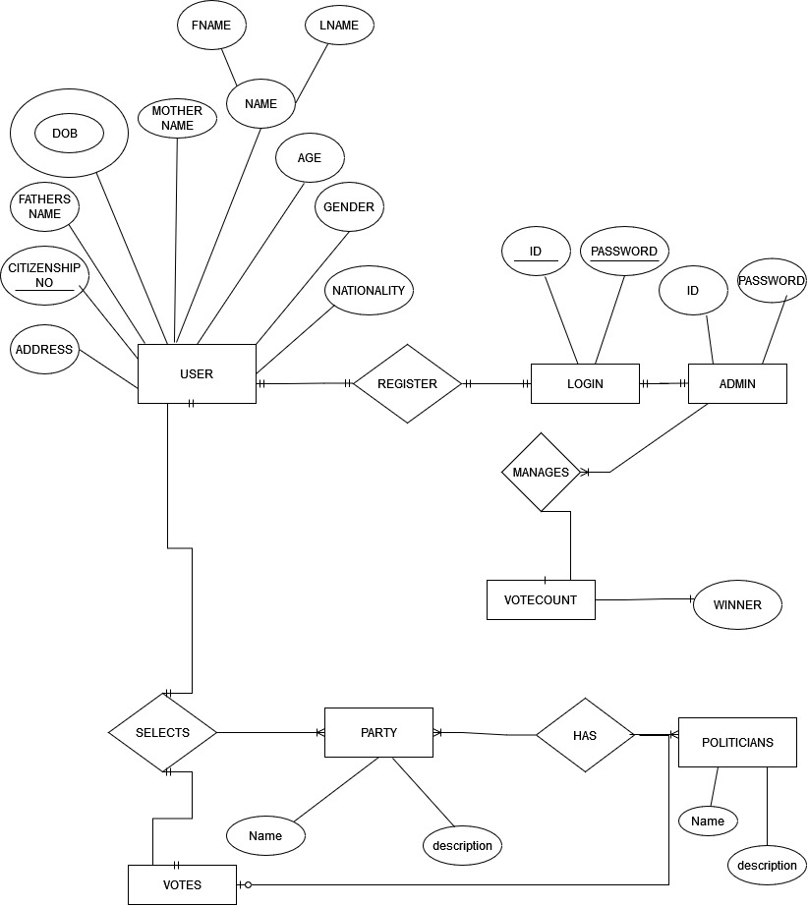

# CHAPTER 4

# REQUIREMENT ANALYSIS & IMPLEMENTATION SYSTEM

## 4.1 Requirements

Hardware Requirement

* PC with Pentium II Processor
* 32 MB of RAM
* Atleast Black and White Monitor
* Hard disk with at least 20MB of free space

Software Requirement

* OS Windows (Windows XP)
* Applications: Dev C++ or other C++ compiler.

## 4.2 System Methodology

System Methodology is a methodology for systematically organizing the best ways to develop systems efficiently. It is a step-by-step process for developing any system. There are many system development methodologies. Some of them are Waterfall Model, Iterative Model, Develope Model, V-Model, Spiral Model, Lean and Agile Model, Prototype Model, etc.

In this project, we are going to use Waterfall Model approach since our project is short and our requirements are fixed. The Waterfall Model is one of the oldest SDLC models but it is best for short projects as this model involves a rigid structure that demands all system requirements be defined at the very start of a project. Only then the design and development stages begin.

**Waterfall Model- Design**

Waterfall approach was the first SDLC Model to be used widely in Software Engineering to ensure success of the project. In “The Waterfall” approach, the whole process of the software development is divided into separate phases. In this Waterfall Model, typically, the outcome of one phase acts as the input for the next phase sequentially.

The following illustration is a representation of the different phases of the Waterfall Model.

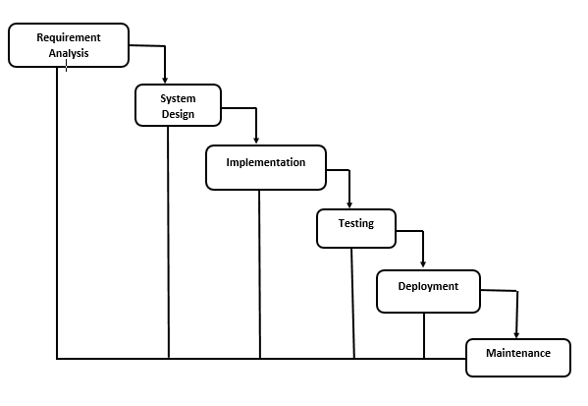

## 4.2.1 Requirement analysis

## Functional requirement

In software and system engineering, a functional requirement defines a function of a system or its component, where a function is described as a specification of behavior between input and outputs.

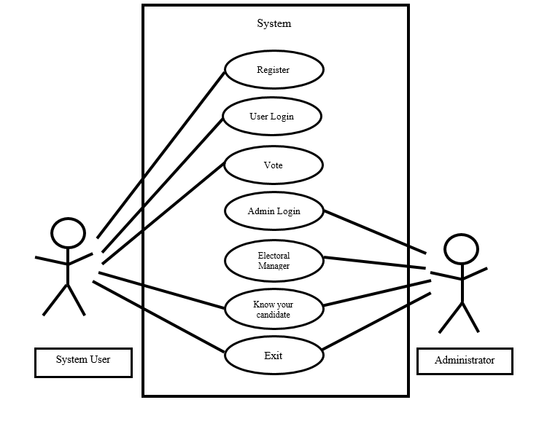

USECASE DIAGRAM

## 4.2.2. System design

This implementation is followed by the next stage in the waterfall model, which is the system design phase. In this section, the requirements that have been analyzed will be translated into detailed design and flowchart of the software code is being created. System design is the important stage that depending on the previous stage to make the great implementation and can be executed properly. When have anything requirements to be insert in designing the code, it will be add up in the requirement analysis phase and the design phase is carried out based on the new set of resources.

* **Importance** :
* If any pre-existing code needs to be understood, organized, and pieced together.
* It is common for the project team to have to write some code and produce original programs that support the application logic of the system.

There are many strategies or techniques for performing system design.

* **Top-down approach:** Top-down integration testing is an integration testing technique used in order to simulate the behavior of the lower-level modules that are not yet integrated. Each system is divided into several subsystems and components. Each of the subsystems is further divided into a set of subsystems and components.
* **Advantages of top-down approach:**
* The main advantage of the top-down approach is that its strong focus on requirements helps to make a design responsive according to its requirements.

### 4.2.2.1 Functional analysis

|  |  |
| --- | --- |
| **void choice()** | To enter all the options displayed on the home screen. |
| **void reg()** | To display all the details required for registration of the user. |
| **void vote()** | To display all the competing parties and their respective representatives . |
| **void gen()** | To generate login id and password of the user. |
| **void log()** | To ask the login id and password of the electoral manager. |
| **void votec()** | To count the number of votes casted for respective parties. |
| **void tc()** | To count the total number of votes and hence display the winner. |
| **void know()** | To know the details of the candidates and hence helps the voters to cast the vote to the candidate they like. |

## 4.2.3. Implementation

With inputs from the system design, the system is first developed in small programs called units, which are integrated in the next phase. Each unit is developed and tested for its functionality, which is referred to as Unit Testing.

* We used C ++programming to implement our project.
* File Handling was used for the data and records.
* Functions for sub modules.
* The system is first developed in small programs called units, which are integrated in the next phase. The testing of each developed unit individually is referred as unit testing.

### 

## 4.2.4. Integration and testing

The complete coding will follow by the testing department where it testing based on the functional and non-functional requirements. It checks if there is any problem in the designed software and if it follows the specifications. At this stage, testing activity will include the involvement of computer technician and client. Here, the good flow of the process in designing the software will ensure satisfaction from the client. If there is any problem with the design, it must be reverted back to the system design. Coding and testing are repeated again.

## 4.2.5. Deployment and maintenance

Once the functional and nonfunctional testing is done, the product  
is deployed in the customer environment or released into the market.  
There are some issues which come up in the client environment. To fix those  
issues patches are released. Also to enhance the product some better versions are released. Maintenance is done to deliver these changes in the customer environment.

# CHAPTER 5

# CONCLUSION AND FUTURE SCOPE

## 5.1Conclusion

The demise of the paper ballot. They are relatively easy to produce, easy to mark and easy to count.Electronic identity systems are being developed to ensure that citizens can participate in the new electronic world of commerce and government.  As more and more daily activities such as paying bills and consulting bank accounts is done electronically, the need to secure reliable electronic identity systems pressure the development and implementation of country-wide and world-wide methods of uniquely identifying people by electronic means.

With electronic service delivery, there is no need for the service provider to be in the same suburb, city or even country as the user.  A scenario can be envisaged whereby a local election management body can locate its office anywhere it is convenient for a variety of reasons and its services can be remotely delivered via Internet, wireless and satellite communications or by whatever new technology are invented to replace current technologies.

As electronic devices become cheaper, more powerful and more secure, it can be expected that the use of a variety of inexpensive, reliable electronic voting methods accelerates and become more widely used.

.

## 5.2 Future scope

* **The demise of the paper ballot:** They are relatively easy to produce, easy to mark and easy to count
* **The rise of electronic voting methods :**As electronic devices become cheaper, more powerful and more secure, it can be expected that the use of a variety of inexpensive, reliable electronic voting methods accelerates and become more widely used.
* **Electronic identities:** Electronic identity systems are being developed to ensure that citizens can participate in the new electronic world of commerce and government.  As more and more daily activities such as paying bills and consulting bank accounts is done electronically, the need to secure reliable electronic identity systems pressure the development and implementation of country-wide and world-wide methods of uniquely identifying people by electronic means.

# REFERENCES

Balagurusamy, E. (June 16, 2011). *Object Oriented Programming with C++ .* Tata McGraw Hill Education Private Limited.

Carter, E. (January 2010). *Electoral Systems and Election Management*. Retrieved from researchgate.net: https://www.researchgate.net/publication/237654779_Electoral_Systems_and_Election_Management

Jeffrey A. Hoffer, J. F. ((May 1, 1996)). *Modern Systems Analysis and Design.* ‎ Benjamin-Cummings Pub Co.

*Online Election System Project*. (2018). Retrieved from nevonprojects.com: https://nevonprojects.com/online-election-system-project/

# Chapter 6

# Appendix

## Screenshots

**1.Main Menu**

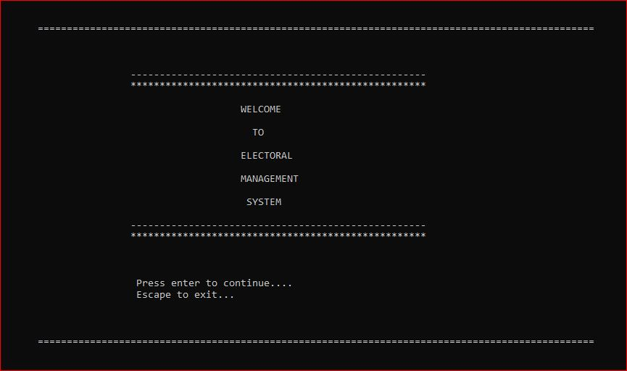

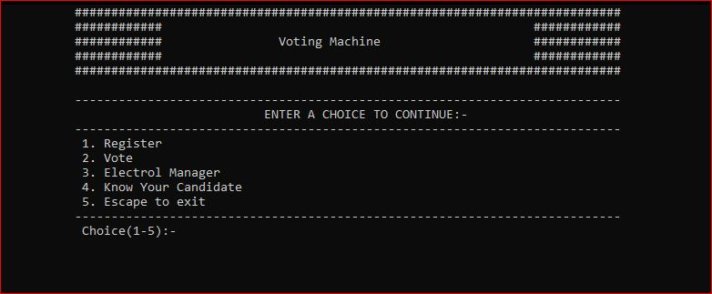

**2. Registration**

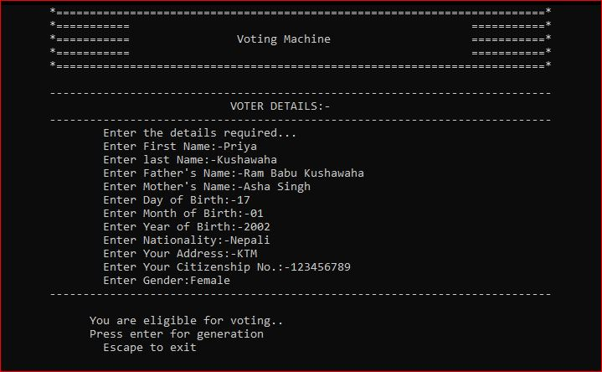

**3. Generation of ID and Password**

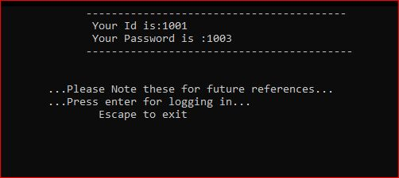

**4.Enterring ID and Password**

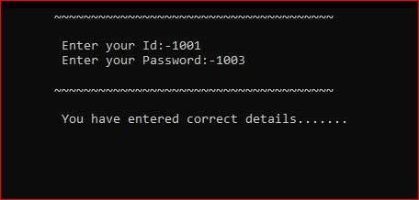

**5.Casting the Vote**

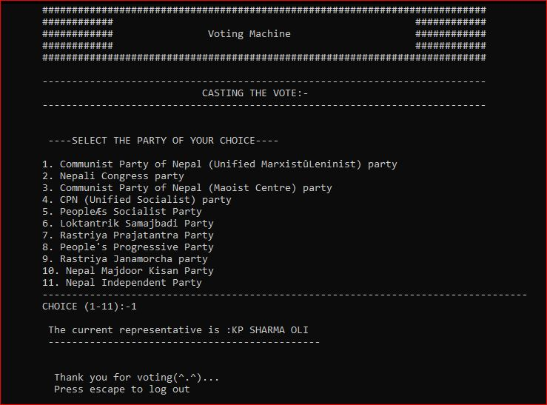

**6.Electoral Manager’s Password**

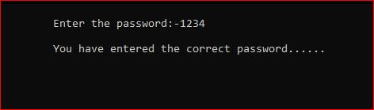

**7.Result Display**

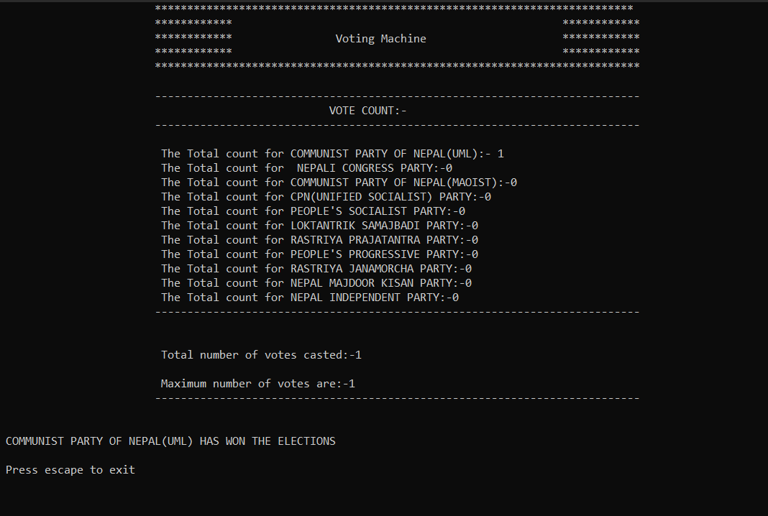

# Chapter 7

# Source Code

/**************Electoral Process Management System Project**************/

#include<iostream>

#include<conio.h>

#include<stdlib.h>

#include<fstream>

using namespace std;

void file()

{

int temp=0;

ofstream fout;

fout.open("Communist Party of Nepal (Unified Marxist–Leninist).txt");

fout<<temp;

fout.close();

ofstream fout1;

fout1.open("Nepali Congress party.txt");

fout1<<temp;

fout1.close();

ofstream fout2;

fout2.open("Maoist Party.txt");

fout2<<temp;

fout2.close();

ofstream fout3;

fout3.open("People's Progressive Party.txt");

fout3<<temp;

fout3.close();

ofstream fout4;

fout4.open("CPN.txt");

fout4<<temp;

fout4.close();

ofstream fout5;

fout5.open("People’s Socialist Party.txt");

fout5<<temp;

fout5.close();

ofstream fout6;

fout6.open("Loktantrik Samajbadi Party.txt");

fout6<<temp;

fout6.close();

ofstream fout7;

fout7.open("Rastriya Prajatantra Party.txt");

fout7<<temp;

fout7.close();

ofstream fout9;

fout9.open("Nepal Majdoor Kisan Party.txt");

fout9<<temp;

fout9.close();

ofstream fout8;

fout8.open("Nepal Independent Party.txt");

fout8<<temp;

fout8.close();

}

static int count=1000;

int p1=0;

int p2=0;

int p3=0;

int p4=0;

int p5=0;

int p6=0;

int p7=0;

int p8=0;

int p9=0;

int p10=0;

int p11=0;

int id;

int pass;

class sel

{

int s;

char name[20],lname[20], fname[20], mname[20], nat[10],pl[10] ,g[10];

double c;

int dob,mob,yob;

public:

void choice();

void reg();

void log();

void gen();

void votec();

void vote();

void tc();

void know();

};

void sel::choice()

{

system("cls");

cout<<"\t\t\t#########################################################";

cout<<"\n\t\t\t############ ############";

cout<<"\n\t\t\t############ Voting Machine ############";

cout<<"\n\t\t\t############ ############";

cout<<"\n\t\t\t########################################################";

cout<<"\n\n\t\t\t---------------------------------------------------------------------------\n";

cout<<"\t\t\t\t\t\t ENTER A CHOICE TO CONTINUE:-"<<endl;

cout<<"\t\t\t---------------------------------------------------------------------------\n";

cout<<"\t\t\t 1. Register"<<endl;

cout<<"\t\t\t 2. Vote"<<endl;

cout<<"\t\t\t 3. Electrol Manager"<<endl;

cout<<"\t\t\t 4. Know Your Candidate"<<endl;

cout<<"\t\t\t 5. Escape to exit"<<endl;

cout<<"\t\t\t---------------------------------------------------------------------------\n";

cout<<"\t\t\t Choice(1-5):-";

cin>>s;

/*************For register**************/

if(s==1)

{

reg();

}

/*********************For Login*****************/

else if(s==2)

{

log();

}

/**************Admin Login Password***************/

else if(s==3)

{

int elepass=1234, enelepass;

char c;

clrscr();

system("cls");

cout<<"\n\t\t\t Enter the password:-";

cin>>enelepass;

if(elepass==enelepass)

{

cout<<endl;

cout<<"\t\t\t You have entered the correct password......";

c=getch();

if(c==13)

{

votec();

}

else if(c==27)

{

exit(0);

}

}

else

{

cout<<"\n\t\t\t You have entered incorrect password. Try again!!!....";

c=getch();

}

}

else if(s==4)

{

know();

}

if(s==5)

{

exit(0);

}

}

/************Showing the registration of voter with their details*****************/

void sel::reg()

{

char c,c1;

clrscr();

system("cls");

cout<<"\t\t\t*=================================================*";

cout<<"\n\t\t\t*=========== ===========*";

cout<<"\n\t\t\t*=========== Voting Machine ===========*";

cout<<"\n\t\t\t*=========== ===========*";

cout<<"\n\t\t\t*================================================*";

cout<<"\n\n\t\t\t---------------------------------------------------------------------------\n";

cout<<"\t\t\t\t\t\t VOTER DETAILS:-"<<endl;

cout<<"\t\t\t---------------------------------------------------------------------------\n";

cout<<"\t\t\t\tEnter the details required...\n";

cout<<"\t\t\t\tEnter First Name:-";

cin>>name;

fflush(stdin);

cout<<"\t\t\t\tEnter last Name:-";

cin>>lname;

fflush(stdin);

cout<<"\t\t\t\tEnter Father's Name:-";

cin>>fname;

fflush(stdin);

cout<<"\t\t\t\tEnter Mother's Name:-";

cin>>mname;

fflush(stdin);

cout<<"\t\t\t\tEnter Day of Birth:-";

cin>>dob;

cout<<"\t\t\t\tEnter Month of Birth:-";

cin>>mob;

cout<<"\t\t\t\tEnter Year of Birth:-";

cin>>yob;

ofstream fout;

fout.open("Register.txt",ios :: app);

if(!fout)

{

cout<<"could not open file: \n";

getch();

}

else

{

fout<<name<<"\t\t\t"<<lname<<"\t\t\t"<<fname<<"\t\t\t"<<mname<<"\t\t\t"< <dob<< "\t\t\t"<<mob<<"\t\t\t"<<yob<<"\t\t\t";

fout.close();

}

/************Showing the voters age must be 18 or above*****************/

if(yob>=2004)

{

cout<<"\n\t\t\t Sorry!!!......You are not eligible for Voting.";

cout<<"\n\t\t\t Press escape to exit";

c1=getch();

if(c1==27)

{

exit(0);

}

}

else

{

ofstream fout;

fout.open("Register.txt",ios::app);

cout<<"\t\t\t\tEnter Nationality:-";

cin>>nat;

fflush(stdin);

cout<<"\t\t\t\tEnter Your Address:-";

cin>>pl;

fflush(stdin);

cout<<"\t\t\t\tEnter Your Citizenship No.:-";

cin>>c;

fflush(stdin);

cout<<"\t\t\t\tEnter Gender:";

cin>>g;

fout<<nat<<"\t\t\t"<<pl<<"\t\t\t"<<c<<"\t\t\t"<<g<<endl;

fout.close();

fflush(stdin);

cout<<"\t\t\t---------------------------------------------------------------------------\n";

cout<<"\n\t\t\t You are eligible for voting..";

cout<<"\n\t\t\t Press enter for generation\n";

cout<<"\t\t\t Escape to exit\n";

c=getch();

if(c==13)

{

clrscr();

count++;

gen();

}

if(c==27)

{

exit(0);

}

}

}

/******************Generating Id and Password*******************/

void sel::gen()

{

char c;

id=count;

pass=count+2;

system("cls");

cout<<"\t\t\t-----------------------------------------";

cout<<"\n\t\t\t Your Id is:"<<id;

cout<<"\n\t\t\t Your Password is :"<<pass;

cout<<"\n\t\t\t------------------------------------------\n";

cout<<"\n\n\t\t ...Please Note these for future references...";

cout<<"\n\t\t ...Press enter for logging in...\n";

cout<<"\t\t\t Escape to exit\n";

c=getch();

if(c==13)

{

log();

}

if(c==27)

{

exit(0);

}

}

/******************logging with unique Id and password to vote******************/

void sel::log()

{

int identer, passenter;

char c;

clrscr();

system("cls");

cout<<"\t\t\t~~~~~~~~~~~~~~~~~~~~~~~~~~~~~~~~~~~~~~\n";

cout<<"\n\t\t\t Enter your Id:-";

cin>>identer;

cout<<"\t\t\t Enter your Password:-";

cin>>passenter;

cout<<"\n\t\t\t~~~~~~~~~~~~~~~~~~~~~~~~~~~~~~~~~~~~~~\n";

if((id==identer)&&(pass==passenter))

{

cout<<endl;

cout<<"\t\t\t You have entered correct details.......";

c=getch();

vote();

}

else

{

cout<<endl;

cout<<"\t\t\t Your id or password is incorrect. please try again!!!!.....";

c=getch();

}

}

/*******Initiating castvote function to allow the user to choose their parties********/

void sel::vote()

{

int opt,ch=0;

char c;

system("cls");

cout<<"\t\t\t#########################################################";

cout<<"\n\t\t\t############ ############";

cout<<"\n\t\t\t############ Voting Machine ############";

cout<<"\n\t\t\t############ ############";

cout<<"\n\t\t\t########################################################";

cout<<"\n\n\t\t\t---------------------------------------------------------------------------\n";

cout<<"\t\t\t\t\t\t CASTING THE VOTE:-"<<endl;

cout<<"\t\t\t---------------------------------------------------------------------------\n";

flag:

/*****************List of Politician Party*************************/

cout<<"\n\n\t\t\t ----SELECT THE PARTY OF YOUR CHOICE----\n\n";

cout<<"\t\t\t1. Communist Party of Nepal (Unified Marxist–Leninist) party \n";

cout<<"\t\t\t2. Nepali Congress party \n";

cout<<"\t\t\t3. Communist Party of Nepal (Maoist Centre) party \n";

cout<<"\t\t\t4. CPN (Unified Socialist) party \n";

cout<<"\t\t\t5. People’s Socialist Party \n";

cout<<"\t\t\t6. Loktantrik Samajbadi Party \n";

cout<<"\t\t\t7. Rastriya Prajatantra Party \n";

cout<<"\t\t\t8. People's Progressive Party \n";

cout<<"\t\t\t9. Rastriya Janamorcha party \n";

cout<<"\t\t\t10. Nepal Majdoor Kisan Party \n";

cout<<"\t\t\t11. Nepal Independent Party\n";

cout<<"\t\t\t----------------------------------------------------------------------------------\n";

cout<<"\t\t\tCHOICE (1-11):-";

cin>>opt;

/****************showing thier representative party leader******************/

switch(opt)

{

case 1:

{

cout<<"\n\t\t\t The current representative is :KP SHARMA OLI";

p1++;

cout<<"\n\t\t\t ----------------------------------------------\n";

ifstream fin;

fin.open("Communist Party of Nepal (Unified Marxist–Leninist).txt",ios::in);

{

while(fin)

{

fin>>ch;

cout<<ch;

break;

}

ch=ch+1;

ofstream fout;

fout.open("Communist Party of Nepal (Unified Marxist– Leninist).txt");

fout<<ch;

fout.close();

}

fin.close();

break;

}

case 2:

{

cout<<"\n\t\t\t The current representative is :SHER BAHADUR DEUBA";

p2++;

cout<<"\n\t\t\t --------------------------------------------------\n";

ifstream fin;

fin.open("Nepali Congress party.txt",ios::in);

{

while(fin)

{

fin>>ch;

ch++;

break;

}

}

fin.close();

ofstream fout;

fout.open("Nepali Congress party.txt");

fout<<ch;

fout.close();

break;

}

case 3:

{

cout<<"\n\t\t\t The current representative is :PUSHPA KAMAL DAHAL";

p3++;

cout<<"\n\t\t\t --------------------------------------------------\n";

ifstream fin;

fin.open("Maoist Party.txt",ios::in);

{

while(fin)

{

fin>>ch;

ch++;

break;

}

}

fin.close();

ofstream fout;

fout.open("Maoist Party.txt");

fout<<ch;

fout.close();

break;

}

case 4:

{

cout<<"\n\t\t\t The current representative is :MADHAV KUMAR NEPAL";

p4++;

cout<<"\n\t\t\t -------------------------------------------------\n";

ifstream fin;

fin.open("CPN.txt",ios::in);

{

while(fin)

{

fin>>ch;

ch++;

break;

}

}

fin.close();

ofstream fout;

fout.open("CPN.txt");

fout<<ch;

fout.close();

break;

}

case 5:

{

cout<<"\n\t\t\t The current representative is :UPENDRA YADAV";

p5++;

cout<<"\n\t\t\t ----------------------------------------------\n";

ifstream fin;

fin.open("People’s Socialist Party.txt",ios::in);

{

while(fin)

{

fin>>ch;

ch++;

break;

}

}

fin.close();

ofstream fout;

fout.open("People’s Socialist Party.txt");

fout<<ch;

fout.close();

break;

}

case 6:

{

cout<<"\n\t\t\t The current representative is :MAHANTHA THAKUR";

p6++;

cout<<"\n\t\t\t ----------------------------------------------\n";

ifstream fin;

fin.open("Loktantrik Samajbadi Party.txt",ios::in);

{

while(fin)

{

fin>>ch;

ch++;

break;

}

}

fin.close();

ofstream fout;

fout.open("Loktantrik Samajbadi Party.txt");

fout<<ch;

fout.close();

break;

}

case 7:

{

cout<<"\n\t\t\t The current representative is :RAJENDRA PRASAD LINGDEN";

p7++;

cout<<"\n\t\t\t -------------------------------------------------------\n";

ifstream fin;

fin.open("Rastriya Prajatantra Party.txt",ios::in);

{

while(fin)

{

fin>>ch;

ch++;

break;

}

}

fin.close();

ofstream fout;

fout.open("Rastriya Prajatantra Party.txt");

fout<<ch;

fout.close();

break;

}

case 8:

{

cout<<"\n\t\t\t The current representative is :HRIDAYESH TRIPATHI";

p8++;

cout<<"\n\t\t\t --------------------------------------------------\n";

ifstream fin;

fin.open("People's Progressive Party.txt",ios::in);

{

while(fin)

{

fin>>ch;

ch++;

break;

}

}

fin.close();

ofstream fout;

fout.open("People's Progressive Party.txt");

fout<<ch;

fout.close();

break;

}

case 9:

{

cout<<"\n\t\t\t The current representative is :CHITRA BAHADUR K.C.";

p9++;

cout<<"\n\t\t\t --------------------------------------------------\n";

ifstream fin;

fin.open("Rastriya janamorcha Party.txt",ios::in);

{

while(fin)

{

fin>>ch;

ch++;

break;

}

}

fin.close();

ofstream fout;

fout.open("Rastriya janamorcha Party.txt");

fout<<ch;

fout.close();

break;

}

case 10:

{

cout<<"\n\t\t\t The current representative is :NARANYAN MAN BIJUKCHHE";

p10++;

cout<<"\n\t\t\t ----------------------------------------------------\n";

ifstream fin;

fin.open("Nepal Majdoor Kisan Party.txt",ios::in);

{

while(fin)

{

fin>>ch;

ch++;

break;

}

}

fin.close();

ofstream fout;

fout.open("Nepal Majdoor Kisan Party.txt");

fout<<ch;

fout.close();

break;

}

case 11:

{

cout<<"\n\t\t\t The current representative is :RAVI LAMICHHANE";

p11++;

cout<<"\n\t\t\t -----------------------------------------------\n";

ifstream fin;

fin.open("Nepal Independent Party.txt",ios::in);

{

while(fin)

{

fin>>ch;

ch++;

break;

}

}

fin.close();

ofstream fout;

fout.open("Nepal Independent Party.txt");

fout<<ch;

fout.close();

break;

}

default:

{

system("cls");

cout<<"\n Select a valid option\n";

goto flag;

break;

}

}

cout<<"\n\n\t\t\t Thank you for voting(^.^)...";

cout<<"\n\t\t\t Press escape to log out";

c=getch();

if(c==27)

{

choice();

}

else

{

cout<<"\n Press valid key";

}

clrscr();

}

/**************calculating the vote count which is seen by only admin*******************/

void sel::votec()

{

char c;

int count[11];

clrscr();

system("cls");

cout<<"\t\t\t***************************************************************";

cout<<"\n\t\t\t************ ************";

cout<<"\n\t\t\t************ Voting Machine ************";

cout<<"\n\t\t\t************ ************";

cout<<"\n\t\t\t*************************************************************";

cout<<"\n\n\t\t\t---------------------------------------------------------------------------\n";

cout<<"\t\t\t\t\t\t VOTE COUNT:-"<<endl;

cout<<"\t\t\t---------------------------------------------------------------------------\n";

ifstream fin;

fin.open("Communist Party of Nepal (Unified Marxist–Leninist).txt",ios::in);

{

while(fin)

{

fin>>count[0];

break;

}

}

fin.close();

cout<<"\n\t\t\t The Total count for COMMUNIST PARTY OF NEPAL(UML):- "<<count[0];

ifstream fin1;

fin1.open("Nepali Congress party.txt",ios::in);

{

while(fin1)

{

fin1>>count[1];

break;

}

}

fin1.close();

cout<<"\n\t\t\t The Total count for NEPALI CONGRESS PARTY:-"<<count[1];

ifstream fin2;

fin2.open("Maoist Party.txt",ios::in);

{

while(fin2)

{

fin2>>count[2];

break;

}

}

fin2.close();

cout<<"\n\t\t\t The Total count for COMMUNIST PARTY OF NEPAL(MAOIST):-"<<count[2];

ifstream fin3;

fin3.open("CPN.txt",ios::in);

{

while(fin3)

{

fin3>>count[3];

break;

}

}

fin3.close();

cout<<"\n\t\t\t The Total count for CPN(UNIFIED SOCIALIST) PARTY:-"<<count[3];

ifstream fin4;

fin4.open("People’s Socialist Party.txt",ios::in);

{

while(fin4)

{

fin4>>count[4];

break;

}

}

fin4.close();

cout<<"\n\t\t\t The Total count for PEOPLE'S SOCIALIST PARTY:-"<<count[4];

ifstream fin5;

fin5.open("Loktantrik Samajbadi Party.txt",ios::in);

{

while(fin5)

{

fin5>>count[5];

break;

}

}

fin5.close();

cout<<"\n\t\t\t The Total count for LOKTANTRIK SAMAJBADI PARTY:-"<<count[5];

ifstream fin6;

fin6.open("Rastriya Prajatantra Party.txt",ios::in);

{

while(fin6)

{

fin6>>count[6];

break;

}

}

fin6.close();

cout<<"\n\t\t\t The Total count for RASTRIYA PRAJATANTRA PARTY:-"<<count[6];

ifstream fin7;

fin7.open("People's Progressive Party.txt",ios::in);

{

while(fin7)

{

fin7>>count[7];

break;

}

}

fin7.close();

cout<<"\n\t\t\t The Total count for PEOPLE'S PROGRESSIVE PARTY:-"<<count[7];

ifstream fin8;

fin8.open("Rastriya Janamorcha Party.txt",ios::in);

{

while(fin8)

{

fin8>>count[8];

break;

}

}

fin8.close();

cout<<"\n\t\t\t The Total count for RASTRIYA JANAMORCHA PARTY:-"<<count[8];

ifstream fin9;

fin9.open("Nepal Majdoor Kisan Party.txt",ios::in);

{

while(fin9)

{

fin9>>count[9];

break;

}

}

fin9.close();

cout<<"\n\t\t\t The Total count for NEPAL MAJDOOR KISAN PARTY:-"<<count[9];

ifstream fin10;

fin10.open("Nepal Independent Party.txt",ios::in);

{

while(fin10)

{

fin10>>count[10];

break;

}

}

fin10.close();

cout<<"\n\t\t\t The Total count for NEPAL INDEPENDENT PARTY:-"<<count[10];

cout<<"\n\t\t\t---------------------------------------------------------------------------\n";

tc();

cout<<"\n\n Press escape to exit";

c=getch();

if(c==27)

{

exit(0);

}

else

{

cout<<"\n Press valid key";

}

}

/*********************Displaying the Total count of all the parties****************/

void sel::tc()

{

int tvc=0;

int max=0,i;

int maxi[10];

maxi[0]=p1;

maxi[1]=p2;

maxi[2]=p3;

maxi[3]=p4;

maxi[4]=p5;

maxi[5]=p6;

maxi[6]=p7;

maxi[7]=p8;

maxi[8]=p9;

maxi[9]=p10;

maxi[10]=p11;

for(i=0;i<11;i++)

{

tvc=tvc+maxi[i];

if(maxi[i]>max)

{

max=maxi[i];

}

}

cout<<"\n\n\t\t\t Total number of votes casted:-"<<tvc;

cout<<"\n\n\t\t\t Maximum number of votes are:-"<<max;

cout<<"\n\t\t\t---------------------------------------------------------------------------\n";

/***********showing the which party is going to win the election******************/

if(p1==max)

{

cout<<"\n\n COMMUNIST PARTY OF NEPAL(UML) HAS WON THE ELECTIONS";

}

else if(p2==max)

{

cout<<"\n\n NEPALI CONGRESS PARTY HAS WON THE ELECTIONS";

}

else if(p3==max)

{

cout<<"\n\n COMMUNIST PARTY OF NEPAL(MAOIST) HAS WON THE ELECTIONS";

}

else if(p4==max)

{

cout<<"\n\n CPN(UNIFIED SOCIALIST) PARTY HAS WON THE ELECTIONS";

}

else if(p5==max)

{

cout<<"\n\n PEOPLE'S SOCIALIST PARTY HAS WON THE ELECTIONS";

}

else if(p6==max)

{

cout<<"\n\n LOKTANTRIK SAMAJBADI PARTY HAS WON THE ELECTIONS";

}

else if(p7==max)

{

cout<<"\n RASTRIYA PRAJATANTRA PARTY HAS WON THE ELECTIONS";

}

else if(p8==max)

{

cout<<"\n\n PEOPLE'S PROGRESSIVE PARTY HAS WON THE ELECTIONS";

}

else if(p9==max)

{

cout<<"\n\n RASTRIYA JANAMORCHA PARTY HAS WON THE ELECTIONS";

}

else if(p10==max)

{

cout<<"\n\n NEPAL MAJDOOR KISAN PARTY HAS WON THE ELECTIONS";

}

else if(p11==max)

{

cout<<"\n\n NEPAL INDEPENDENT PARTY HAS WON THE ELECTIONS";

}

else

{

cout<<"\n\n NONE PARTY HAS WON THE ELECTIONS";

}

}

/*************Displaying the details of the respective Candidate*******************/

void sel::know()

{

int details;

char c;

system("cls");

cout<<"\t\t\t#####################################################################"; cout<<"\n\t\t\t############ ############";

cout<<"\n\t\t\t############ Voting Machine ############";

cout<<"\n\t\t\t############ ############";

cout<<"\n\t\t\t###################################################################";

cout<<"\n\n\t\t\t---------------------------------------------------------------------------\n";

cout<<"\t\t\t\t\t\t LIST OF CANDIDATE:-"<<endl;

cout<<"\t\t\t---------------------------------------------------------------------------\n";

label:

/***************************List of Candidate****************************/

cout<<"\n\n ----CHOOSE ANY CANDIDATE TO KNOW THEIR DETAILS----\n\n";

cout<<"1. KP SHARMA OLI \n";

cout<<"2. SHER BAHADUR DEUBA \n";

cout<<"3. PUSHPA KAMAL DAHAL\n";

cout<<"4. MADHAV KUMAR NEPAL \n";

cout<<"5. UPENDRA YADAV \n";

cout<<"6. MAHANTHA THAKUR \n";

cout<<"7. RAJENDRA PRASAD LINGDEN \n";

cout<<"8. HRIDAYESH TRIPATHI\n";

cout<<"9. CHITRA BAHADUR K.C. \n";

cout<<"10.NARANYAN MAN BIJUKCHHE\n";

cout<<"11.RAVI LAMICHHANE \n";

cout<<"---------------------------------------------------------------------------------------------------------\n";

cout<<"CHOICE (1-11):-";

c=getch();

cin>>details;

system("cls");

switch(details)

{

case 1:

{

cout<<"\n\t\t\t\t KP SHARMA OLI";

cout<<"\n\t\t\t\t=================";

cout<<"\n\t Khadga Prasad Sharma Oli is a Nepalese politician and former Prime Minister of Nepal.";

cout<<"\n He strengthened relations with China as an alternative to Nepal's traditional close trade ties with India ";

cout<<"\n and updated the map of Nepal by constitutional amendment including territories disputed with India,";

cout<<"\n for which he has received some domestic praise and a reputation as a nationalist.";

cout<<"\n Oli began his political career in 1966 in opposition to the partyless Panchayat system in place at the time.";

cout<<"\n\n\t\t Thank you!!!...PLease vote for COMMUNIST PARTY OF NEPAL(UML).";

break;

}

case 2:

{

cout<<"\n\t\t\t\t SHER BAHADUR DEUBA";

cout<<"\n\t\t\t\t ===================";

cout<<"\n Sher Bahadur Deuba is a Nepali legislator filling in as the top state leader of Nepal";

cout<<"\n since 13 July 2021.He has additionally been filling in as the leader of the Nepali Congress ";

cout<<"\n beginning around 2016.Deuba has recently served four terms as the state head (1995-1997, ";

cout<<"\n 2001-2002, 2004-2005, and 2017-2018) and is the Member of Parliament for";

cout<<"\n the parliamentary supporters of Dadeldhura 1.";

cout<<"\n\n\t\t Thank you!!!...PLease vote for NEPALI CONGRESS PARTY.";

break;

}

case 3:

{

cout<<"\n\t\t\t\t PUSHPA KAMAL DAHAL";

cout<<"\n\t\t\t\t ===================";

cout<<"\n Pushpa Kamal Dahal likewise well known as Prachanda signifying 'wild', is a Nepalese legislator";

cout<<"\n who filled in as Prime Minister of Nepal from 2008 to 2009 and again from 2016 to 2017.";

cout<<"\n Dahal was the head of the Communist Party of Nepal (Maoist) during the country's affable conflict";

cout<<"\n and resulting harmony process and the first Nepalese constituent gathering. In the 2008 decisions,";

cout<<"\n CPN(M) arose as the biggest party, and Dahal became Prime Minister in August of that year.";

cout<<"\n\n\t\t Thank you!!!...PLease vote for COMMUNIST PARTY OF NEPAL(MAOIST).”;

break;

}

case 4:

{

cout<<"\n\t\t\t\t MADHAV KUMAR NEPAL";

cout<<"\n\t\t\t\t ===================";

cout<<"\n Madhav Kumar Nepal is a Nepalese legislator and previous Prime Minister of Nepal.";

cout<<"\n He filled in as Prime Minister of Nepal from 25 May 2009 to 6 February 2011 for almost two years.";

cout<<"\n He turned into the 34th Prime Minister of Nepal on 25 May 2009 after his ancestor Prachanda ";

cout<<"\n surrendered over a contention with the president over the excusal of the military's head of staff.";

cout<<"\n\n\t\t Thank you!!!...PLease vote for CPN(UNIFIED SOCIALIST) PARTY.";

break;

}

case 5:

{

cout<<"\n\t\t\t\t UPENDRA YADAV";

cout<<"\n\t\t\t\t================";

cout<<"\n Upendra Yadav is a Nepalese politician who has served as the chairman of the People's";

cout<<"\n Socialist Party, Nepal since 2020.He has been the Member of Parliament for Saptari 2 since 2017.";

cout<<"\n He served as the Deputy Prime Minister of Nepal under the government of KP Sharma Oli";

cout<<"\n from 2018 to 2020 and is one of the closest leader to Oli.";

cout<<"\n\n\t\t Thank you!!!...PLease vote for PEOPLE'S SOCIALIST PARTY.";

break;

}

case 6:

{

cout<<"\n\t\t\t\t MAHANTHA THAKUR";

cout<<"\n\t\t\t\t==================";

cout<<"\n Mahantha Thakur is the president of the new party. Mahantha Thakur is a";

cout<<"\n Nepalese politician and president of Loktantrik Samajbadi Party Nepal, as well as";

cout<<"\n the former treasurer of Nepali Congress Party. He has served Minister in various ministries";

cout<<"\n including Ministry Of Science and Technology while in Nepali Congress. ";

cout<<"\n\n\t\t Thank you!!!...PLease vote for LOKTANTRIK SAMAJBADI PARTY.";

break;

}

case 7:

{

cout<<"\n\t\t\t\t RAJENDRA PRASAD LINGDEN";

cout<<"\n\t\t\t\t=========================";

cout<<"\n Rajendra Prasad Lingden is a Nepali legislator, having a place with";

cout<<"\n the Rastriya Prajatantra Party, at present filling in as the individual from ";

cout<<"\n the first Federal Parliament of Nepal. In the 2017 Nepalese general political race,";

cout<<"\n he was chosen from the Jhapa 3 body electorate, getting 44614 (56.52%)votes.It was";

cout<<"\n shaped by previous state leaders Surya Bahadur Thapa and Lokendra Bahadur Chand,";

cout<<"\n who served two terms each as state head since the finish of the Rastriya Panchayat.";

cout<<"\n\n\t\t Thank you!!!...PLease vote for RASTRIYA PRAJATANTRA PARTY.";

break;

}

case 8:

{

cout<<"\n\t\t\t\t HRIDAYESH TRIPATHI";

cout<<"\n\t\t\t\t=====================";

cout<<"\n Hridayesh Tripathi is a Nepalese politician, belonging to the";

cout<<"\n People's Progressive Party. He's also the current chairman of the party. ";

cout<<"\n A former Minister of Health and Population Tripathi was worked several terms";

cout<<"\n as minister under the government of Nepali Congress and CPN (UML).";

cout<<"\n\n\t\t Thank you!!!...PLease vote for PEOPLE'S PROGRESSIVE PARTY.";

break;

}

case 9:

{

cout<<"\n\t\t\t\t CHITRA BAHADUR K.C.";

cout<<"\n\t\t\t\t======================";

cout<<"\n Former Deputy Prime Minister, Chitra Bahdur KC is the chairman of the party.";

cout<<"\n Chitra Bahadur K.C.is a Nepalese politician and Former Deputy Prime Minister and Minister";

cout<<"\n of Poverty Alleviation Of Nepal. He is current chairman of the Rashtriya Jana Morcha";

cout<<"\n\n\t\t Thank you!!!...PLease vote for RASTRIYA JANAMORCHA PARTY.";

break;

}

case 10:

{

cout<<"\n\t\t\t\t NARANYAN MAN BIJUKCHHE";

cout<<"\n\t\t\t\t========================";

cout<<"\n Narayan Man Bijukchhe is a Nepalese politician.";

cout<<"\n He became a communist sympathizer after seeing the relief work of Communist Party";

cout<<"\n of Nepal cadres during floods in Rautahat around 1954. Around 1956 he joined the Students Federation";

cout<<"\n and became a Communist Party member the following year. ";

cout<<"\n\n\t\t Thank you!!!...PLease vote for NEPAL MAJDOOR KISAN PARTY.";

break;

}

case 11:

{

cout<<"\n\t\t\t\t RAVI LAMICHHANE";

cout<<"\n\t\t\t\t==================";

cout<<"\n Former media personality Ravi Lamichhane has opened a new political party - ";

cout<<"\n the National Independent Party. Lamichhane announced the National Independent Party ";

cout<<"\n amidst an event organized at the City Hall today.Lamichhane also demanded provisions for";

cout<<"\n a directly elected Prime Minister and chief ministers. Before announcing the party, he said that";

cout<<"\n he has joined politics not to change the system but to change the situation of the people";

cout<<"\n\n\t\t Thank you!!!...PLease vote for NEPAL INDEPENDENT PARTY.";

break;

}

default:

{

system("cls");

cout<<"\n Select a valid option\n";

goto label;

break;

}

}

cout<<endl;

cout<<"\n\n\n\t\t\t Press Enter to know details of another candidate!!!";

cout<<"\n\t\t\t Press escape to log out...";

c=getch();

if(c==13)

{

know();

}

if(c==27)

{

choice();

}

else

{

cout<<"\n Press valid key";

}

clrscr();

}

int main()

{

char c;

int i;

ifstream fin;

fin.open("Nepali Congress party.txt");

{

if(!fin)

{

file();

fin.close();

}

else

{

fin.close();

}

}

clrscr();

sel s[20];

cout<<"\n";

cout<<"\n\t\t======================================================";

cout<<"\n\n\n\n\t\t\t\t---------------------------------------------------\n";

cout<<"\t\t\t\t***************************************************\n";

cout<<"\n";

cout<<"\t\t\t\t\t\t WELCOME \n\n";

cout<<"\t\t\t\t\t\t TO \n\n";

cout<<"\t\t\t\t\t\t ELECTORAL \n\n";

cout<<"\t\t\t\t\t\t MANAGEMENT \n\n";

cout<<"\t\t\t\t\t\t SYSTEM \n";

cout<<"\n";

cout<<"\t\t\t\t---------------------------------------------------\n";

cout<<"\t\t\t\t***************************************************\n";

cout<<"\n";

cout<<"\n\n\t\t\t\t Press enter to continue....\n";

cout<<"\t\t\t\t Escape to exit...";

cout<<"\n\n\n\n\t\t================================================";

c=getch();

if(c==13)

{

for(i=0;i<20;i++)

{

s[i].choice();

}

}

else if(c==27)

{

exit(0);

}

else

{

cout<<"\n Press a valid key\n";

getch();

}

}